4.0 Interface Description

4.1 Module Interface

4.1.1 Login Page Module Description

4.1.1.1 User Interface Design

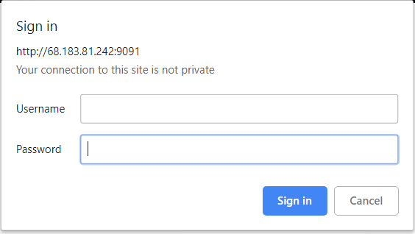

Figure 1. IP address, transmission port number, username, password.



Figure 2. Unauthorized Page

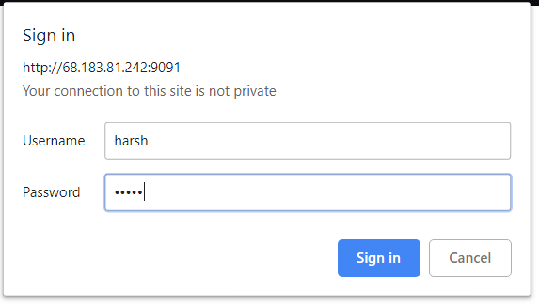  
Figure 3. Credentials filled.

4.1.1.2 Description

The landing page of the site brings the customer to this screen where he can login using his ID and password. Incorrect credentials will allow the user to again enter the credentials.

After the validation of the password and the user ID he will be redirected to the main home page.

If user decides to press cancel the this window alert will vanish and the page will be left blank.

4.1.1.3 Use Case Diagram

4.1.2 Downloading Module

4.1.2.1 User Interface Design

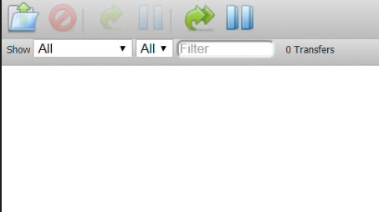

Figure 4. Download icon

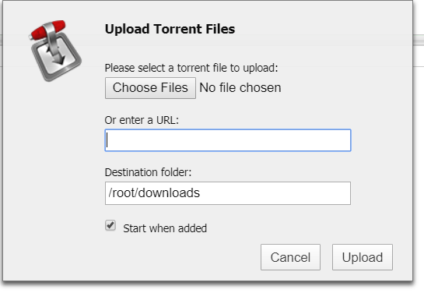

Figure 5. Download Screen with url

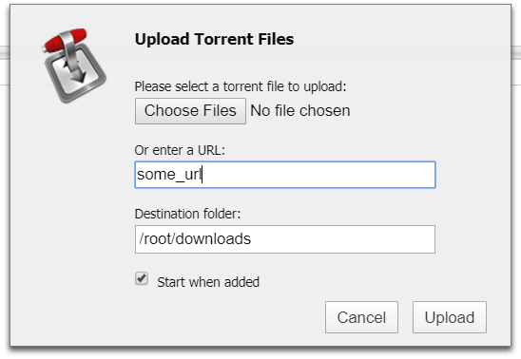

Figure 6. URL enter

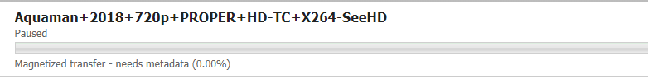

Figure 7. Download Started.

4.1.2.2 Description

The download screen can be reached using the icon showed and will show a pop-up window. The user then can choose to Enter his own URL or can choose a torrent file from the PC. After the user presses the Upload button, the files starts downloading on the server.

4.1.2.3 Use Case Diagram

4.1.3 Torrent Manage Module

4.1.3.1 User Interface



Figure 8 Basic Control for Torrent

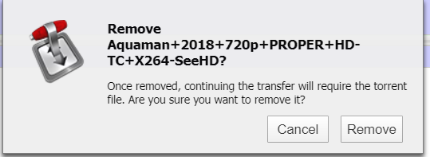

Figure 9 Torrent removal

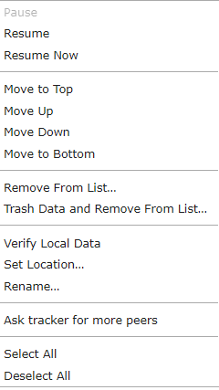

Figure 10 Detailed Controls

4.1.3.2 Description

The basic controls allow the user to pause, stop, delete the selected torrent and it’s files. The user would be prompted for confirmation regarding the same through a window alert. The other more advanced features could be used using the right click feature on the desired active/inactive torrent.

4.1.3.3 Use case

4.1.4 Transmission Control Panel

4.1.4.1 User Interface



Figure 11 Configuration, Settings

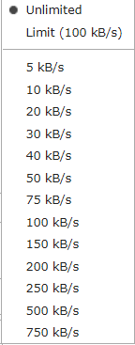

Figure 11 Set download/upload rate

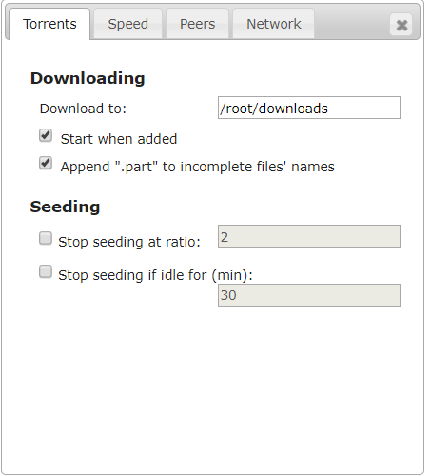

Figure 12 Detailed Configuration

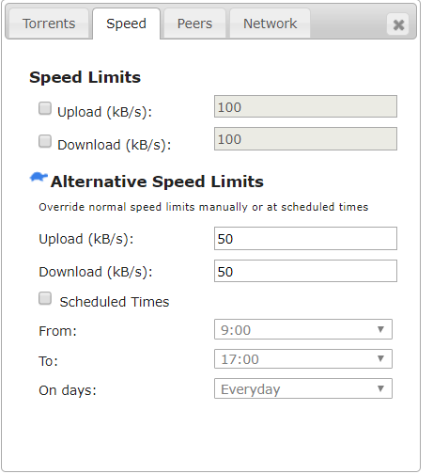

Figure 13 Speed control

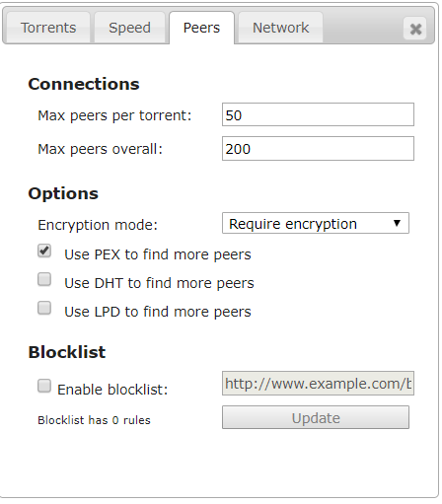

Figure 14 Advance Control for peer selection

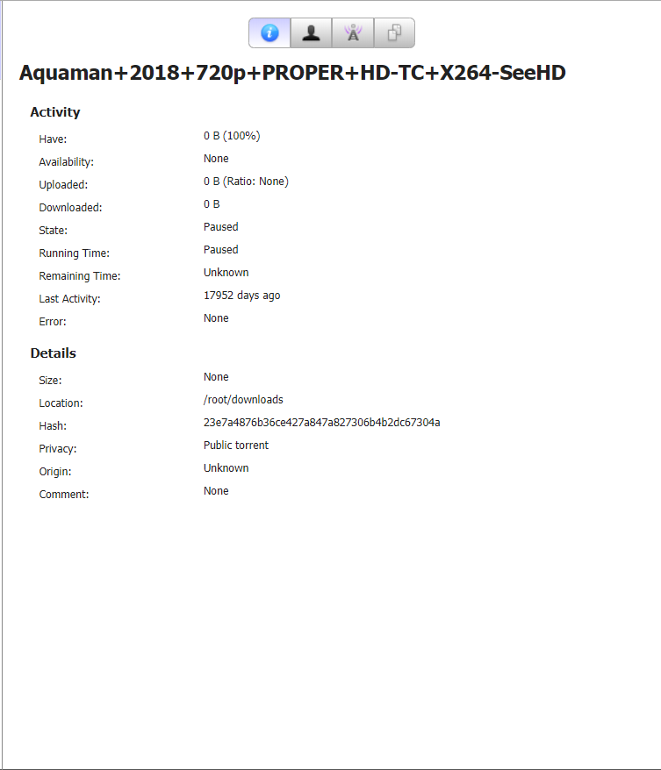

Figure 15 Detail stats on torrent

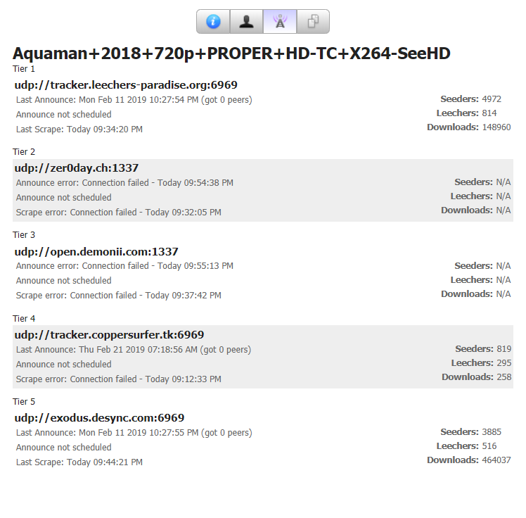

Figure 16 Tracker Information

4.1.4.2 Description

The transmission control panel would provide the user to manage the download speed of the torrent and other activities including the peer list and trackers. It also allows the user to change the directory for the downloads for all the download taking place in the future. The user can also alter the speed with which the downloads take place.

4.1.4.3 Use Case Diagram